Exercise 2: E-commerce Platform Search Function
Data Structures and Algorithms – Week 1, Cognizant Assessment

Scenario
The task was to optimize the search functionality of an e-commerce platform by implementing and comparing two classic search algorithms — linear search and binary search — over a catalog of products.

1. Asymptotic Notation
Big O notation describes how the running time (or memory use) of an algorithm grows as the size of its input grows. It strips away constant factors and hardware differences, so it becomes a way to compare algorithms based purely on how they scale, rather than how fast one particular machine happens to run them.
For a search operation, three scenarios are usually considered:
- Best case: the target is found almost immediately (e.g., first element checked in linear search, or the middle element in binary search). Typically O(1).
- Average case: the typical number of comparisons across all possible positions of the target. Roughly n/2 for linear search, and around log₂(n) for binary search.
- Worst case: the target is in the least convenient position, or missing entirely, forcing the maximum possible number of comparisons — O(n) for linear search, O(log n) for binary search.

2. Setup – Product Class
A simple Product class was created to hold the fields the search functions operate on: productId, productName, and category.
public class Product {
private int productId;
private String productName;
private String category;

public Product(int productId, String productName, String category) {
this.productId = productId;
this.productName = productName;
this.category = category;
}

public int getProductId() { return productId; }
public String getProductName() { return productName; }
public String getCategory() { return category; }

@Override
public String toString() {
return "Product{id=" + productId + ", name='" + productName
+ "', category='" + category + "'}";
}
}

3. Implementation
Linear search was implemented to work directly on an unsorted array of products, checking each entry in turn:
public class LinearSearch {

public static Product search(Product[] products, int targetId) {
for (int i = 0; i < products.length; i++) {
if (products[i].getProductId() == targetId) {
return products[i];
}
}
return null;
}
}
Binary search was implemented to work on a copy of the array sorted by productId, repeatedly halving the search range:
public class BinarySearch {

public static Product search(Product[] sortedProducts, int targetId) {
int low = 0;
int high = sortedProducts.length - 1;

while (low <= high) {
int mid = (low + high) / 2;
int midId = sortedProducts[mid].getProductId();

if (midId == targetId) {
return sortedProducts[mid];
} else if (midId < targetId) {
low = mid + 1;
} else {
high = mid - 1;
}
}
return null;
}
}
Both algorithms were exercised from a single SearchDemo class, which builds the product catalog, times a linear search and a binary search for the same productId, and prints the result of each:
Product[] products = { ... 10 sample products ... };
int searchId = 108;

// Linear search on the unsorted array
Product foundLinear = LinearSearch.search(products, searchId);

// Binary search needs the array sorted by productId first
Product[] sortedProducts = products.clone();
Arrays.sort(sortedProducts, Comparator.comparingInt(Product::getProductId));
Product foundBinary = BinarySearch.search(sortedProducts, searchId);

4. Output
Running SearchDemo in IntelliJ IDEA produced the following console output, confirming both algorithms located the same product (Coffee Maker, id 108) correctly:
---- Linear Search ----
Found: Product{id=108, name='Coffee Maker', category='Home Appliances'}
Time taken: 313000 ns

---- Binary Search ----
Found: Product{id=108, name='Coffee Maker', category='Home Appliances'}
Time taken: 451800 ns

Process finished with exit code 0
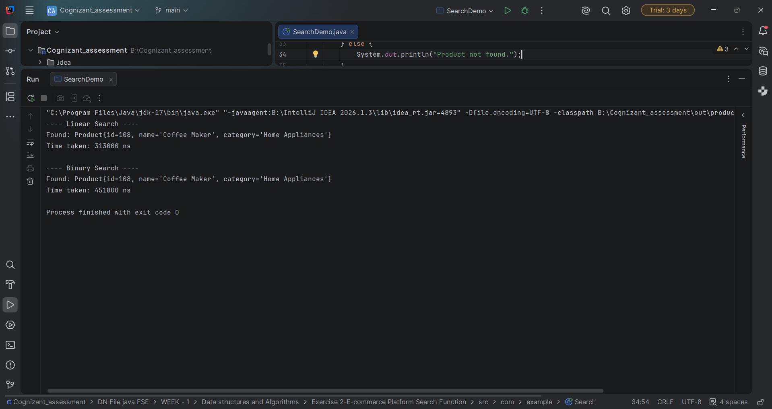
Screenshot: IntelliJ IDEA run console showing the output of SearchDemo.java.

5. Analysis
Linear search runs in O(n) time in both the average and worst case, since it may need to check every element before finding the target or concluding it isn't present. It has the advantage of working on any array, sorted or not.
Binary search runs in O(log n) time in the average and worst case, since each comparison eliminates half of the remaining search space. The trade-off is that it requires the array to be sorted first, which itself costs O(n log n) if the data isn't already ordered.
In this run, linear search actually completed faster in raw nanoseconds (313,000 ns vs 451,800 ns) than binary search. This is expected for a small catalog of only 10 products — with so few elements, the overhead of sorting the array before searching (plus JIT warm-up on the first method call) outweighs the theoretical advantage of binary search. The O(log n) benefit of binary search only becomes visible at much larger catalog sizes.
For an e-commerce platform, binary search is the more suitable long-term choice once the catalog is large, since searches (reads) happen far more often than the catalog changes (writes). Maintaining a sorted index lets lookups by productId scale to millions of products in around 20 comparisons instead of up to a million. Linear search remains useful for smaller lists or for searching by fields that aren't sorted/indexed, such as free-text matches on productName.

